Certification of personnel for environmental sampling – experience from 10 years of practice
K. Björklöf; A. Joutti, 14.5.2010
Finnish Environment Institute, P.O. Box 140, FI-00251 Helsinki, Finland

"There is no point in spending time and money on careful sample preparation and testing if the quality of the samples is poor" EPA 1992.

Challenges of environmental sampling
The complexities of diverse natural environments can make truly representative sampling a tricky task and incorrect sampling will greatly distort research findings. Sampling may in many cases be the most demanding part of environmental measurements. This is mainly due to natural heterogeneity of the environment in space and time. The competence of the sampling personnel is therefore critical for representative environmental sampling. E.g. in soil, sampling one 20 g sample may represent only 0.0001 % of the total focus of the investigation. Important and costly decisions such as remediation of contaminated soils are made based on the results from samplings.

The certification scheme
To improve the quality of environmental sampling, a special system to certify qualified sampling personnel was established at the Finnish Environment Institute (SYKE) in 1999. This system is set up according to the SFS-EN ISO/IEC 17024:2003 standard and is accredited since 2004 by FINAS. In ten years more than 500 certificates have been granted.

Sampling personnel with more than two years of experience in environmental sampling and who have passed the introductory and specialization courses with accepted examination may apply for certification. The courses provide knowledge about technical, practical and regulatory aspects of sampling. Certified persons may qualify in one or more fields of specialization (Table 1). The certificate is granted for eight years. The total costs for the applicant is 2 000 €, including the fees for two courses. During the certification period the sampling personnel are obligated to maintain and develop their competence by further training. A new examination is required for recertification (Figure 1).

To oversee the certification of sampling personnel, an expert group has been set up, which consists of a group of experts from different fields of sampling. Their work is in turn overseen by a certification board, whose members represent the Ministry of the Environment, the Ministry of Health and Social Affairs, environmental organizations, consultants, providers of technical training and the employers of sampling personnel. In addition the certification body has a wide network of collaboration partners (Figure 2).

Conclusions
The certification system has in ten years developed from a govermental tool to a widely acknowledged quality assureance procedure. The quality of sampling has improved both in govermental monitoring programs as well as in sampling procedures in private companies. Today more than 50 % of the certified sampling personnel are working in private companies (Figure 3). Private companies benefit from this documented quality assurance procedure, because certification of the sampling personnel is providing them competitive advantage. Education of sampling personnel has improved significantly due to this certification system. More courses are available and the contents of the courses have improved. Certified persons are also more motivated to regularly take part in training courses.

Accreditation or certification?
Accreditation is the process applied by national accrediting bodies to determine whether any organization has fulfilled pre-specified training criteria (eg. ISO/IEC 17025). Accreditation requires preparations of detailed manuals and written procedures instructions. It may however be difficult to establish sufficiently detailed guidelines for environmental sampling, where all factors of uncertainty and exceptions are difficult to describe. In these cases the role of the sampling personnel during field work is crucial. Certification of sampling personnel is a mean to control the quality also in unforeseen situations. These two quality assurance procedures are therefore not mutually exclusive but complement each other (Figure 4).

Table 1. Amount of certified samplers in different fields of specializations in 2010 in Finland.
Field of specialization | Number of specialized sampling personnel
Water samples | 331 (86 %)
Soil samples and samples of solid wastes | 234 (61%)
Environmental measurements and observations | 44 (11%)
Biological samples | 13 (3%)
Air and atmospheric deposition samples | 3 (1%)

Figure 1. The certification process.

Figure 2. Network of collaboration partners.

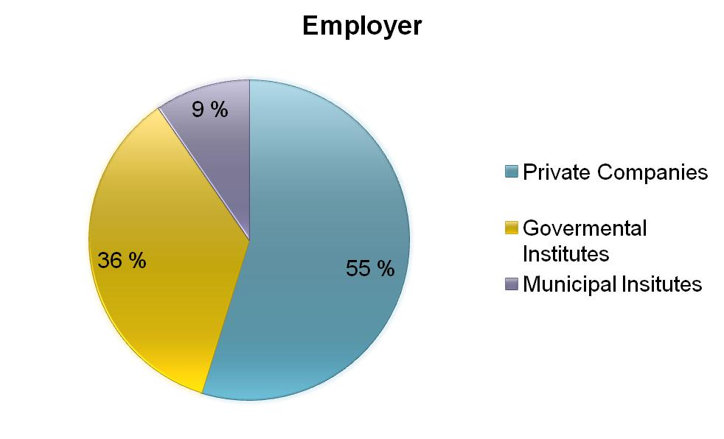
Figure 3. Employers of certified samplers in 2009 in Finland.

Figure 4. Relationship between accreditation and certification as quality assurance procedures in environmental sampling.

Tämä jää pois:
1. Agreement with providers of training
2. Applicant gets experience 2y
3. Applicant takes courses
4. Applicant passes examinations
5. Applicant apply for certification
6. Certification body evaluates and makes a decision.
7. Sampling personnel maintains skills
8. Sampling personnel for recertification
9. Certification body evaluates and makes a decision on recertification
10. Sampling personnel may complain about decisions
11. Certification board support and supervise
12. Certification body reports annually.

